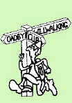
NEWSLETTER -March 2019
Oadby Hillwalking Club
www.oadbyhwc.com

OHWC COMMITTEE 2018-19
Chairperson: Jenny Fox 0116-2911491
Secretary/Newsletter: Fiona Clarkson 0116-2793372
Treasurer: Alison Beckett 07557 199247
Walks Co-ordinator: Geoff Mattock 0116-2395381
Social: Eileen Pott 0780 0774029
Membership Secretary: Carol Hinks 0116-2592144
Dates for your Diaries:
AGM 2019 revised date
The AGM will now take place on Wednesday 1st May 2019. There will be vacancies on the committee, if you would be interested in joining the Committee please talk to any committee member. We would especially like someone with website IT experience.
Snowdonia Weekend July 19th-21st 2019
Geoff Mattock is planning a walking weekend in Wales. Members will need to sort their own accommodation and transport ASAP. Dolgam B&B tel 01690 720228 and campsite just turn up. If you would like to attend this weekend or find out more please contact Geoff.
March Mid Month Walk
Sunday 17th March, Meet at White Hart, Lyddington at 9:30, 8 miles led by Keith Yeomans.
Next monthly walk Sunday 7th April – Disley
Coach departs: Oadby Central Car Park (adjacent to the Trinity Methodist Church) at 8.00am and will leave The Rams Head, Disley at 5:30pm.
Coach Route: M1 J26, A610, A6, A53, A537, B5470, A5004, A6.
Boot stop: Matlock
Maps: Explorer OL1, OL24
Walk Leaders Mike Hinks (8), Adam Wakley (10), John Bastow (11), Geoff (12), Carol Birch (long)
Walk Routes. To Mike Hinks, preferably as a gpx file or alternatively as a JPEG file by Thursday March 21st please. mike.hinks19@gmail.com
Walk Route Map
Please go onto the News section of the Club website, www.oadbyhwc.com a few days before the monthly walk, to see a map showing the walk routes. Hopefully this will speed up selecting your walk when signing up on the coach.
Prospective walkers – please contact the group email address to book a seat on the bus this month: OHWCmail@gmail.com. You will receive a reply confirming the availability or otherwise of a seat. You are reminded that it is first come first served. If you delay booking you may not get a seat. Please do not turn up without booking and receiving confirmation that you have a place. You must book a place on the coach in advance or you may not be allowed on as it picks up at various places on the ring road members who have already booked a seat.
If you wish to be picked up, at other places than the Oadby Car Park, please mention where when booking and please be aware that very occasionally another Woods coach may go past before ours arrives.
Members can book for the next month’s walk on the return journey back to Oadby. You don’t have to wait for the Club meeting or the Newsletter.
Bus Fares – preferably by cheque payable to “Oadby Hillwalking Club” or simply “O.H.W.C.”
Adult Members £12, Junior/Student Members £5, Guests/Visitors + £3. (subject to review at the AGM)

Cancellations - members and guests - Cancellations up to Tuesday Midnight before the Sunday walk - no penalty. Cancellations thereafter - full cost of the bus fare due. (AGM 2011). Please send fare due to the Treasurer, Alison Beckett, 5 Spinney View, Great Glen, Leics, LE8 9EP

Boot/Toilet Stop
Members are urged to keep the time taken at the boot stop to a minimum. At the end of the walk members should change their footwear and place dirty boots and rucksacks in the luggage locker before getting onto the coach, thus avoiding any congestion and mud in the coach.
Those getting off the coach at Fosse Park and the Ring Road, may alternatively, put your dirty kit into a “Bin Liner” and then take it onto the coach; thus negating having to search for your kit in the bus Luggage Locker.

Interested in being a Walk Leader? Please speak to any Committee Member, who will gladly arrange this for you – or better still come along to our Club Meetings.
Monthly Club Meetings
Monthly club meetings are held on the Wednesday following the Sunday walk at the Wigston Conservative Club, 38 Long Street, Wigston, Leicester, LE18 2AH at 7.30pm. All club members are welcome.

Safety Form and Emergency Personal Details
Please make sure that you are carrying your completed Club Safety Form in the top of your rucksack - it could help you in a difficult situation. N.B. Don’t forget to keep the form up to date. The form is available on the Club Website www.oadbyhwc.com
The club walk organisers are not qualified guides. You join them at your own risk and of your own free will. You are part of an autonomous group, responsible for your own safety and happy to accept the discretion and actions of any or all the participants on that organised walk or activity in the event of injury to you, the need to have you rescued or otherwise.
Essential Wear - N.B. Jeans and, or trainers/sandals are NOT suitable
Members and guests must be suitably equipped and as a minimum this must include:
❖ Suitable walking boots
❖ waterproof coat and over-trousers
❖ warm clothing
❖ an appropriate rucksack.
❖ food and drink for the whole day
❖ a First Aid Kit is recommended
If you are not properly equipped for hillwalking you may not be able to participate.
Please do not wear dirty boots on the bus even at the start of the day.
Only “Registered Assistance Dogs” are allowed on club walks except on midmonth walks at the discretion of the walk leader.
Sunday Monthly Walks by coach: 2019/2020
Returns at 5pm during GMT and 5.30pm during BST.
2019
May 12th-Cleeve Hill
2 June Wendover – Chilterns, Bucks
7 July Hayfield – Peak District
4 Aug Knighton - west of M6, Staffs
1 Sept Painswick – Cotswolds
6 Oct Tideswell – Peak District
3 Nov Hope – Peak District
1 Dec Ambergate – Peak District
2020
5 Jan Monyash – Peak District
2 Feb Bradwell – Peak District
1 Mar Blockley – Cotswolds
5 April Symonds Yat - Wye Valley
10 May Hadfield – Peak District

Members Special Offer
The April walk is your last chance to claim your free ride if you haven’t claimed it yet.
Almoner’s Report
If you know of any member that is poorly or unable to walk for any reason, please let one of the committee know.
Mid Month Walk Report
Sunday 17th February Thornton – Ratby Boroughs– Thornton Reservoir 8.5 miles Catherine Gwinnett
Eight walkers set off in the sunshine from the Reservoir Inn, Thornton. We made our way downhill through the fields with a view of the reservoir to our left, before climbing up towards Markfield Lane where we crossed and walked along the bridleway close to Forest Hill golf course. We followed a small path through the Woodland Trust Crow Wood before turning off along the edge of the golf course to reach Ratby Boroughs. After walking through the woods, accompanied by birdsong, we continued past Holy Well before reaching the outskirts of Ratby where we had a short break while Geoff ate his xmas cake. The return towards Thornton included the lovely woods with lots of signs that Spring is well on its way. The final part of the walk was around the reservoir where we saw water birds on the water and a large flock of geese grazing in a field. We ended our walk with a drink sitting outside the Bricklayers Arm
March Walk Report, Elton Griffin
An Egg in a Car
The 11 mile walk around Hathersage
Alighting from the bus, we set off under the guidance of our leader, Geoff Mattock. Within seconds I was gasping for air as Geoff began walking at a pace that would make Usain Bolt look like a blue badge holder. It was as if he decided to put his roller skates on and relive some of his past achievements. Having moved quicker than faeces off a shovel, it didn’t take us long to leave the village and pass a rare sight in this beautiful part of the world.
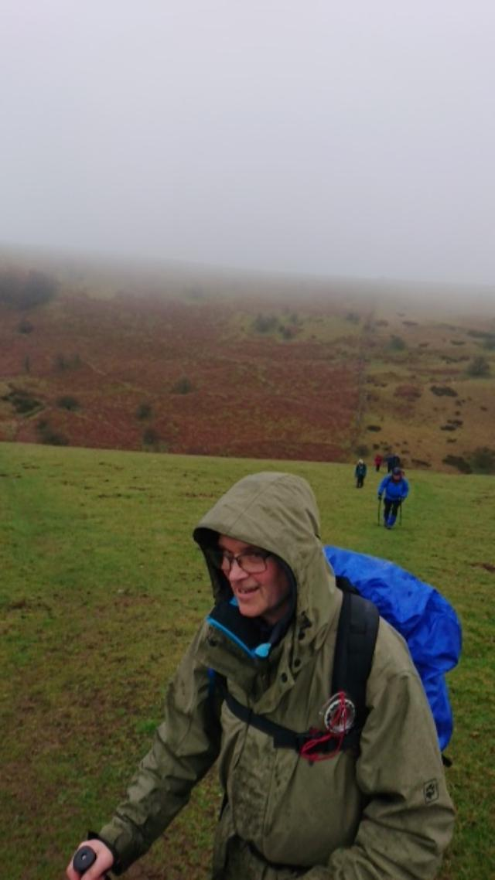
Backdale Quarry is a good sized scar that runs along the path we were taking. Even though it’s ugliness was strangely mesmerising, the mining of limestone thankfully ended a few years ago. There are rare shark bone fossils and wildlife habitats within it. Shortly after seeing this, we had to say “Goodbye” to someone who became ill. A person kindly escorted him to Hathersage, whereupon he was immediately administered with a lifesaving drug that is better than anything prescribed on the NHS: alcohol. We bade farewell to them and had a tea break shortly after.
Chomping in two different groups, Geoff outdid everyone with the intriguing contents of his lunchbox: a small, blue toy car. We were on tenterhooks as he lifted the little roof to reveal a perfectly boiled egg which looked like an oversized airbag. It prompted a flurry of questions worthy of a Question Time audience: Was the egg cooked in or out of the car? How did the person know it was ready? Would the car body affect the cooking time? Geoff was as perplexed as we were but we ventured on despite these unanswered questions.
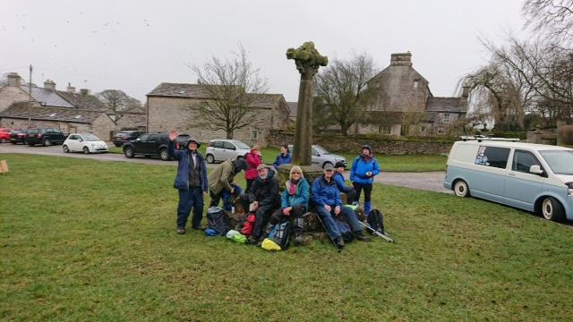
As we made our way across Longstone Moor we were met with startled grouse which darted into the air with their signature squawking sounds. Maybe they were worried their babies would end up in someones toy car? After this we had an early lunch in the delightful village of Foolow whilst sitting on the hexagonal shaped monument in the village centre. This stone structure had a cross that was pilfered from a chapel in 1868 and an old bullring that was on a stone at the side of it. An advert for “Sexwax” was proudly displayed on a surfers campervan nearby. I wasn’t sure what this was but it put me off my cheese and pickle sandwiches.
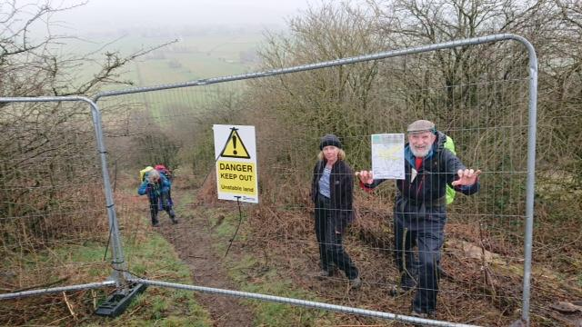
Wending our way across moor, peak and dale we came across a steep bank which terminated at the top courtesy of a metal cage barrier. We in in Oadby Hillwalking Club are never deterred by anything and a brave maverick levered it open for the rest of us to follow. A sign that was attached to this warned walkers to keep out as the ground was unstable due to mineshafts in the area. This warning was not displayed at the bottom of the slope which we had just traipsed up. We proceeded onwards towards Offerton Hall and past Cockey Farm.
Though an unassuming building, Cockey Farm is the birthplace of ‘The Peak Minstrel’ William Newton, a labouring class poet who made his fortune at nearby Cressbrook Mill. None of his sonnets and poems were at the back of my mind as we walked quickly along the river into Hathersage for some well-earned drinks and other refreshments.
Sunday 3rd February, 2019 –Monsal Head – Short Walk Ju;ie Hart
The weather was cold, windy, sunny and cloudy in turn. Snow covered grassy fields, some uneven and downhill tracks through woodland. Conditions were slippery from mud, ice and packed snow on footpaths in places, a normal winter’s walk really. We set off from Baslow walking through the Chatsworth Estate over the River Derwent then on and up, through Edensor, the closest village to Chatsworth House, much of it belonging to the Dukes of Devonshire. Still gradually climbing we turned and looked back at the clear views of the Chatsworth House and the countryside in the distance. We continued uphill along a short path through woodland and across snow covered fields where ‘snow angels’ were attempted and photographed, then on past an iced covered expanse of water and down along a steep mud and snow covered trail through woodland, past a golf course and joined the Monsal Trail. The trail was very busy with families enjoying the winter sunshine and we joined them at the Cycle Hire and café at Hassop Station where we ate our sandwiches. After a puzzling time rounding up and then losing some of our number, we finally set off leaving the Monsal trail to Toll Bars House. We crossed fields and joined Mires Lane to Great Longstone. We made our way through the village and on towards Little Longstone where we went in search of The Monsal Trail tunnel which would take us to the end of our route. We arrived back at the coach, as did two other groups; it was getting cold by now, so quickly into the Monsal Head Hotel for a cuppa or a pint (maybe something stronger) and a relaxing chat. A very enjoyable adventure, thanks Jenny.

