NEWSLETTER - September 2019
Oadby Hillwalking Club www.oadbyhwc.com

OHWC Committee 2019-2020
Chair: Jenny Fox 0116 2911491
Secretary/Newsletter: Catherine Gwinnett 07941855762
Treasurer: Alison Beckett 07557199247
Walks Co-ordinator: Geoff Mattock 0116 2395381
Membership Secretary: Carol Hinks 0116 2592144

Monthly Club Meetings
Monthly club meetings are held on the Wednesday following the Sunday walk at the Wigston Conservative Club, 38 Long Street, Wigston, Leicester, LE18 2AH at 7.30pm. All club members are welcome.

September Mid-month walk
Keith is leading an 8 mile circular walk on Sunday 16th September. Meet at The Black Horse, Main Street, Foxton, LE16 7RD at 9.15 ready to set off at 9.30
If you would like to lead a mid-month walk, please let Geoff know.

Social events
Chef and Spice Charity Meal
In aid of Derbyshire, Leicestershire and Rutland Air Ambulance.
7pm Monday 28th October.
Tickets available on the October coach or via Jenny.

OHWC Christmas Dinner
Thursday 12 December 2019 at 6:30pm
£23 for a 3 course meal with coffee
Licensed bar
TASTE RESTAURANT
Leicester College,
Floor 2, Freemen’s Park Campus, Welford Road, LE2 7LW

If you would like to attend then the full amount of £23.00 is payable when you add your name to the list with your menu choices. See attachment for the menu.

There are a number of ways to add your name to the list and pay: -

1. Email the club with menu choices and pay by bank transfer (contact Alison for bank details)

2. Email the club with menu choices and send a cheque for £23.00 payable to OHWC (contact Alison for address)

3. Add your name to the list on the October bus walk with menu choices and give cheque for £23.00 payable to OHWC.

Charity Walk Support
Mirtha Wright is taking part in a sponsored Coast to Coast walk in support of LOROS, September 21st – 5th October.
You can help Mirtha raise money for this great cause by donating directly to her fundraising page. JustGiving sends your donation straight to LOROS, the Leicestershire and Rutland Hospice so that they can put your generosity to good use!
https://www.justgiving.com/Mirtha-Wright?utm_source=Sharethis&utm_medium=fundraisingpage&utm_content=Mirtha-Wright&utm_campaign=pfp-email&utm_term=EEkbG64nr
If you are taking part in a charity walk and you would like to have information in the Newsletter, email OHWC.
You will need to have a JustGiving page or a similar fundraising page – no collections on the coach, please.

Walk Report September 2019 Painswick - Sarah Cleaver
11 of us set off near Ullenwood, past a long barrow (1st lesson of the day) towards the Cotswolds Way and Crickley Hill Country Park, its beautiful 250-year-old Beech trees (2nd lesson of the day), Iron Age Fort and luxury (i.e. not behind a bush) toilets.
Rather than us all risk life and limb at the Air Balloon roundabout, Jenny halted a lorry (possibly not intentionally) so we could cross over safely. We were soon back off road and headed towards Birdlip Hill. Having decided it is now a monthly walk tradition not to be ignored, I hurled myself head first at the ground again and had Catherine pour cold water over my wounds.
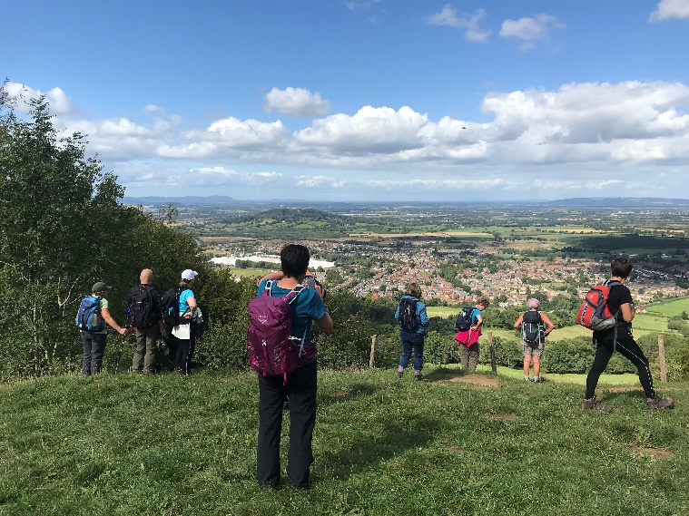
Suitably flushed of grit we ate lunch in the sunshine in a clearing in Witcombe Wood before heading upwards at Coopers Hill; famous for people hurtling down it after a round of cheese.
After looking over the fence for a while, wondering why on earth anyone would want to do that and taking in the stunning view we carried on through Upton Wood. A well attired local gentleman (who was stood watching a mouse!) pointed out that our method of bus drop off and finish is the same rules as a shotgun start golf tournament (3rd lesson of the day.)

The last time we were in this area we saw a slow worm, there wasn’t much fauna around today but a special shout out goes to the very flat snake spotted on the road.

So after a day of walking in perfect weather (crafted by careful navigation around the rain by Catherine), we finally headed across the golf course towards Painswick (looking for a missing dalmatian – not a dull moment to be had today) and St Mary’s 99 yew trees. Legend suggests that the devil would destroy the hundredth if it were ever planted. (4th lesson of the day)

And for the 5th: Every year in September the yew tree clippings produce over 2 tons of material and as they are a good source of the basic raw material for the anti-cancer drug paclitaxel, specialist contractors go to the churchyard to collect and ship them off for processing.

Next monthly walk – Sunday 6th October Hayfield, High Peak, Derbyshire
Please remember that when walking as part of a group it is essential that the group stays within sight of the leader.
Coach departs: Oadby Central Car Park (adjacent to the Trinity Methodist Church) at 8.00am and will leave Hayfield at 5:30pm. Finishing point: The Pack Horse, Market Street, Hayfield.
Coach Route: M1 (J29), A617, A619, A623, A6, A624
Boot stop: Tibshelf
Maps: OS Explorer OL1
Walk Leaders: Carol Birch (long) Geoff Mattock (12) John Bastow (11) Adam Wakley (10) Mike Hinks (8)
Walk Routes. To Mike Hinks, preferably as a gpx file or as a JPEG file by at the latest, please. mike.hinks19@gmail.com
Please contact Carol ohwcmail@gmail.com if you would like to book a place on the coach or if you are unable to go and need to cancel.
All OHWC members can claim one free ride on a monthly walk between October and December 2019.
Walk reminder
Please make sure that you are carrying your completed Club Safety Form in the top of your rucksack - it could help you in a difficult situation. N.B. Don’t forget to keep the form up to date. The form is available on the Club Website oadbyhwc.com/essential-information/
Walk Route Map
Please go onto the News section of the Club website, www.oadbyhwc.com a few days before the monthly walk, to see a map showing the walk routes. Hopefully this will speed up selecting your walk when signing up on the coach.
Prospective walkers – please contact the group email address to book a seat on the bus this month: OHWCmail@gmail.com. You will receive a reply confirming the availability or otherwise of a seat. You are reminded that it is first come first served. If you delay booking you may not get a seat. Please do not turn up without booking and receiving confirmation that you have a place. You must book a place on the coach in advance or you may not be allowed on as it picks up at various places on the ring road members who have already booked a seat.
If you wish to be picked up, at other places than the Oadby Car Park, please mention where when booking and please be aware that very occasionally another Woods coach may go past before ours arrives.
Members can book for the next month’s walk on the return journey back to Oadby. You don’t have to wait for the Club meeting or the Newsletter.
Bus Fares – preferably by cheque payable to “Oadby Hillwalking Club” or simply “O.H.W.C.”
Adult Members £12, Junior/Student Members £5, Guests/Visitors + £3. (subject to review at the AGM)

Cancellations - members and guests - Cancellations up to Tuesday Midnight before the Sunday walk - no penalty. Cancellations thereafter - full cost of the bus fare due. (AGM 2011). Please send fare due to the Treasurer, Alison Beckett, 5 Spinney View, Great Glen, Leics, LE8 9EP

Boot/Toilet Stop
Members are urged to keep the time taken at the boot stop to a minimum. At the end of the walk members should change their footwear and place dirty boots and rucksacks in the luggage locker before getting onto the coach, thus avoiding any congestion and mud in the coach.
Those getting off the coach at Fosse Park and the Ring Road, may alternatively, put your dirty kit into a “Bin Liner” and then take it onto the coach; thus negating having to search for your kit in the bus Luggage Locker.

Interested in being a Walk Leader? Please speak to any Committee Member, who will gladly arrange this for you – or better still come along to our Club Meetings.
Safety: The club walk organisers are not qualified guides. You join them at your own risk and of your own free will. You are part of an autonomous group, responsible for your own safety and happy to accept the discretion and actions of any or all the participants on that organised walk or activity in the event of injury to you, the need to have you rescued or otherwise.
Essential Wear - N.B. Jeans and, or trainers/sandals are NOT suitable
Members and guests must be suitably equipped and as a minimum this must include:
❖ Suitable walking boots
❖ waterproof coat and over-trousers
❖ warm clothing
❖ an appropriate rucksack.
❖ food and drink for the whole day
❖ a First Aid Kit is recommended
If you are not properly equipped for hillwalking, you may not be able to participate.
Please do not wear dirty boots on the coach.
Only Registered Assistance Dogs are allowed on club walks, except on mid-month walks at the discretion of the walk leader.

Sunday Monthly Walks by coach: 2019/2020
Return departure is at 5pm during GMT and 5.30pm during BST.
2019
6 Oct Hayfield – Peak District
3 Nov Hope – Peak District
1 Dec Ambergate – Peak District
2020
5 Jan Monyash – Peak District
2 Feb Bradwell – Peak District
1 Mar Blockley – Cotswolds
5 April Symonds Yat - Wye Valley
10 May Hadfield – Peak District

Almoner’s Report
If you know of any member that is poorly or unable to walk for any reason, please let one of the committee know.

