NEWSLETTER – February 2020
Oadby Hillwalking Club www.oadbyhwc.com
ohwcmail@gmail.com

OHWC Committee 2019-2020
Chair: Jenny Fox 0116 2911491
Secretary/Newsletter: Catherine Gwinnett 07941855762
Treasurer: Alison Beckett 07557199247
Walks Co-ordinator: Geoff Mattock 0116 2395381
Membership Secretary: Carol Hinks 0116 2592144

Monthly Club Meetings
Monthly club meetings are held on the Wednesday following the Sunday walk at the Wigston Conservative Club, 38 Long Street, Wigston, Leicester, LE18 2AH at 7.30pm. All club members are welcome.

News and Events

OHWC AGM
Wednesday 8th April 2020
We urgently need new committee members to take on the roles of Membership Secretary and Social Secretary. Please speak to any of the current committee if you’re interested and would like more information about these roles.

Woodland Trust community tree planting at Queen Elizabeth Woods, Leicestershire
Saturday 7th March
If you’d like to take part, please use this link for further information and to book a place: woodlandtrusttickets.cloudvenue.co.uk/communitytreeplantingatqueenelizabethwoodsleicestershire

Casepak visit - April 15th
This visit is now fully booked. If you would like to put your name on the reserve list, please contact Jenny Fox jennyfox126@gmail.com or phone: 0116 2911491

February Walk Report
Andy McQuaid, walk leader, Long Walk (16 miles), Baslow to Bradwell

Unusually, our walk wasn't the first to leave the coach, in fact it was the third!
There were just five of us braving the still drizzly weather as we left the coach on the outskirts of Baslow and headed towards Chatsworth House. After crossing the bridge across from the house, we left the gravel drive and took a grassy track which followed the banks of the River Derwent towards the first village of our walk - Pilsley. Unfortunately, before reaching the village we came across a padlocked gate signposted 'Private', with horned deer watching us from the other side.
After a quick discussion we agreed to head back across fields (not on a designated footpath) to the village of Edensor. Here we continued through the village and followed an inclined footpath and then a stretch of road, which took us back to our plotted route - but on the other side of Pilsley.
Now back on track, and with the weather improving all the time, we went through Hassop, Rowland and Great Longstone - which I thought was a great place to stop (although not a timely one) but the others disagreed and so we continued on towards Wardlow.
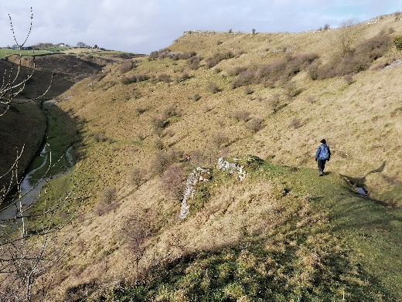
The footpath to the left, before entering Wardlow, took us to Cressbrook Dale.
So far (and, in fact, for the rest of the walk) the walking was heavy going with waterlogged fields and slippery muddy paths.
I mention this because, on the steep climb down into Cressbrook Dale I fell heavily resulting in a pocketful of mud and a slightly bruised ego. Fortunately, this was the only tumble, amongst us all, during the walk.

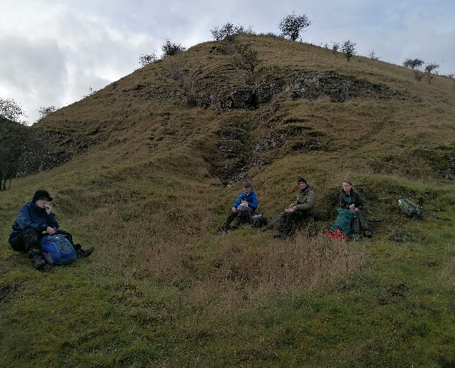
Before taking the shorter and more gradual incline along Tansley Dale and to the village on Litton, it was agreed, at 2.10pm, to pause, sheltered from the wind, to rest, eat lunch and recover our stamina.
After walking through Litton we crossed several fields overlooking the recently visited town of Tideswell, before reaching a familiar road junction at Lane Head. (Some of us recalled making 'snow angels' here during a winter’s walk led by Jenny Fox.) From here was a welcome and fast paced walk along a quiet road to Little Hucklow.
Now we were on the 'home run', with a downhill walk across fields, via Green Dale and into Bradwell.
Surprisingly, but conveniently, it started to rain but not before we had the welcome site of our coach waiting patiently on the roadside. And still with plenty of time for a quick visit to the pub and a well-earned drink!

Mid-month walk Sunday 16th February
Keith Yeomans is leading an 8-mile walk from Foxton. Meet at 9.45 near the church.
You should be able to park in the street.
The conditions are bound to be wet and muddy so make sure you come prepared!

Next monthly walk – Sunday 1st March, Blockley, Cotswolds

Coach departs: Oadby Central Car Park (adjacent to the Trinity Methodist Church) at 8.00am. Please note the coach will leave at 5pm.
Finishing point: The Great Western Arms, Station Road, Blockley, GL56 9DT
Coach Route: M69, A46, A439, B4632, B4077, A429, A44, B4479
Boot stop: Stratford
Map: Explorer OL45
Walk Leaders: Carol (long) Catherine (13) Geoff (12) Adam (10) Colin (8)

Please contact Catherine ohwcmail@gmail.com if you would like to book a place on the coach or if you are unable to go and need to cancel.

Walk reminder
Please make sure that you are carrying your completed Club Safety Form in the top of your rucksack - it could help you in a difficult situation. N.B. Don’t forget to keep the form up to date. The form is available on the Club Website oadbyhwc.com/essential-information/
Walk Route Map: Please go onto the News section of the Club website, www.oadbyhwc.com a few days before the monthly walk, to see a map showing the walk routes. Hopefully this will speed up selecting your walk when signing up on the coach.
Prospective walkers – please contact the group email address to book a seat on the bus this month: OHWCmail@gmail.com. You will receive a reply confirming the availability or otherwise of a seat. You are reminded that it is first come first served. If you delay booking you may not get a seat. Please do not turn up without booking and receiving confirmation that you have a place. You must book a place on the coach in advance or you may not be allowed on as it picks up at various places on the ring road members who have already booked a seat.
If you wish to be picked up, at other places than the Oadby Car Park, please mention where when booking and please be aware that very occasionally another Woods coach may go past before ours arrives.
Members can book for the next month’s walk on the return journey back to Oadby. You don’t have to wait for the Club meeting or the Newsletter.
Bus Fares – preferably by cheque payable to “Oadby Hillwalking Club” or simply “O.H.W.C.”
Adult Members £12, Junior/Student Members £5, Guests/Visitors + £3. (subject to review at the AGM)

Cancellations - members and guests - Cancellations up to Tuesday Midnight before the Sunday walk - no penalty. Cancellations thereafter - full cost of the bus fare due. (AGM 2011). Please send fare due to the Treasurer, Alison Beckett, 5 Spinney View, Great Glen, Leics, LE8 9EP

Boot/Toilet Stop
Members are urged to keep the time taken at the boot stop to a minimum. At the end of the walk members should change their footwear and place dirty boots and rucksacks in the luggage locker before getting onto the coach, thus avoiding any congestion and mud in the coach.
Those getting off the coach at Fosse Park and the Ring Road, may alternatively, put your dirty kit into a “Bin Liner” and then take it onto the coach; thus negating having to search for your kit in the bus Luggage Locker.

Interested in being a Walk Leader? Please speak to any Committee Member, who will gladly arrange this for you – or better still come along to our Club Meetings.
Safety: The club walk organisers are not qualified guides. You join them at your own risk and of your own free will. You are part of an autonomous group, responsible for your own safety and happy to accept the discretion and actions of any or all the participants on that organised walk or activity in the event of injury to you, the need to have you rescued or otherwise.
Essential Wear - N.B. Jeans and, or trainers/sandals are NOT suitable
Members and guests must be suitably equipped and as a minimum this must include:
❖ suitable walking boots
❖ waterproof coat and over-trousers
❖ warm clothing
❖ an appropriate rucksack.
❖ food and drink for the whole day
❖ a First Aid Kit is recommended
If you are not properly equipped for hillwalking, you may not be able to participate.
Please do not wear dirty boots on the coach.
Only Registered Assistance Dogs are allowed on club walks, except on mid-month walks at the discretion of the walk leader.

Sunday Monthly Walks by coach: 2020
Return departure is at 5pm during GMT and 5.30pm during BST.
1 Mar Blockley – Cotswolds
5 April Symonds Yat - Wye Valley
3 May Hadfield – Peak District

Almoner’s Report
If you know of any member who is poorly or unable to walk for any reason, please let one of the committee know.

