NEWSLETTER - July 2019
Oadby Hillwalking Club
www.oadbyhwc.com

OHWC COMMITTEE 2019-20

Chairperson: Jenny Fox 0116-2911491
Secretary/Newsletter: Catherine Gwinnett 07941855762
Treasurer: Alison Beckett 07557 199247
Walks Co-ordinator: Geoff Mattock 0116-2395381
Membership Secretary: Carol Hinks 0116-2592144
Monthly Club Meetings
Monthly club meetings are held on the Wednesday following the Sunday walk at the Wigston Conservative Club, 38 Long Street, Wigston, Leicester, LE18 2AH at 7.30pm. All club members are welcome.

If you left your red Regatta jacket on the coach after the Tideswell walk on Sunday 7th July, please contact ohwc@gmail.com

Next monthly walk – Sunday 4th August, Knighton, Powys
Coach departs: Oadby Central Car Park (adjacent to the Trinity Methodist Church) at 8.00am and will leave the pub in Knighton (TBA) at 5:30pm.
Coach Route: M69, M6, M54, A5, A488
Boot stop: Telford
Maps: OS Explorer 201
Walk Leaders: Mike Hinks (8), Adam Wakley (10), Geoff Mattock (13), Alison Beckett (14), Carol Birch (long)
Walk Routes. To Mike Hinks, preferably as a gpx file or as a JPEG file by 25th July please. mike.hinks19@gmail.com
Please contact Carol ohwcmail@gmail.com if you would like to book a place on the coach or if you are unable to go and need to cancel.

Walk reminder
Please make sure that you are carrying your completed Club Safety Form in the top of your rucksack - it could help you in a difficult situation. N.B. Don’t forget to keep the form up to date. The form is available on the Club Website oadbyhwc.com/essential-information/
Walk Route Map
Please go onto the News section of the Club website, www.oadbyhwc.com a few days before the monthly walk, to see a map showing the walk routes. Hopefully this will speed up selecting your walk when signing up on the coach.
Prospective walkers – please contact the group email address to book a seat on the bus this month: OHWCmail@gmail.com. You will receive a reply confirming the availability or otherwise of a seat. You are reminded that it is first come first served. If you delay booking you may not get a seat. Please do not turn up without booking and receiving confirmation that you have a place. You must book a place on the coach in advance or you may not be allowed on as it picks up at various places on the ring road members who have already booked a seat.
If you wish to be picked up, at other places than the Oadby Car Park, please mention where when booking and please be aware that very occasionally another Woods coach may go past before ours arrives.
Members can book for the next month’s walk on the return journey back to Oadby. You don’t have to wait for the Club meeting or the Newsletter.
Bus Fares – preferably by cheque payable to “Oadby Hillwalking Club” or simply “O.H.W.C.”
Adult Members £12, Junior/Student Members £5, Guests/Visitors + £3. (subject to review at the AGM)

Cancellations - members and guests - Cancellations up to Tuesday Midnight before the Sunday walk - no penalty. Cancellations thereafter - full cost of the bus fare due. (AGM 2011). Please send fare due to the Treasurer, Alison Beckett, 5 Spinney View, Great Glen, Leics, LE8 9EP

Boot/Toilet Stop
Members are urged to keep the time taken at the boot stop to a minimum. At the end of the walk members should change their footwear and place dirty boots and rucksacks in the luggage locker before getting onto the coach, thus avoiding any congestion and mud in the coach.
Those getting off the coach at Fosse Park and the Ring Road, may alternatively, put your dirty kit into a “Bin Liner” and then take it onto the coach; thus negating having to search for your kit in the bus Luggage Locker.

Interested in being a Walk Leader? Please speak to any Committee Member, who will gladly arrange this for you – or better still come along to our Club Meetings.

Safety
The club walk organisers are not qualified guides. You join them at your own risk and of your own free will. You are part of an autonomous group, responsible for your own safety and happy to accept the discretion and actions of any or all the participants on that organised walk or activity in the event of injury to you, the need to have you rescued or otherwise.
Essential Wear - N.B. Jeans and, or trainers/sandals are NOT suitable
Members and guests must be suitably equipped and as a minimum this must include:
❖ Suitable walking boots
❖ waterproof coat and over-trousers
❖ warm clothing
❖ an appropriate rucksack.
❖ food and drink for the whole day
❖ a First Aid Kit is recommended
If you are not properly equipped for hillwalking you may not be able to participate.
Please do not wear dirty boots on the bus even at the start of the day.
Only “Registered Assistance Dogs” are allowed on club walks except on midmonth walks at the discretion of the walk leader.

Sunday Monthly Walks by coach: 2019/2020
Return departure is at 5pm during GMT and 5.30pm during BST.
2019
4 Aug Knighton - Powys
1 Sept Painswick – Cotswolds
6 Oct Hayfield – Peak District
3 Nov Hope – Peak District
1 Dec Ambergate – Peak District
2020
5 Jan Monyash – Peak District
2 Feb Bradwell – Peak District
1 Mar Blockley – Cotswolds
5 April Symonds Yat - Wye Valley
10 May Hadfield – Peak District

Almoner’s Report
If you know of any member that is poorly or unable to walk for any reason, please let one of the committee know.

July Walk Report – Tideswell, Peak District Walk Leader John Bastow.
Written by Colin New
After being on the coach for a long time we welcomed being led downhill rather than the usual steep uphill climb and after a gentle descent we entered a scenic, narrow dale which twisted and turned revealing the rolling beauty of the area.
After ½ mile or so, now in full walking mode we made our first ascent. The grassy dale and limestone walls gave way to ancient woodland in Cressbrook Dale and we soon passed its national nature reserve and quaint but very isolated Ravensdale Cottages.
Continuing southerly, at breaks in the trees we enjoyed glimpses of the surrounding hills, the temperature was warm with a gentle breeze – we had a short break overlooking a stunning valley, the views went for miles towards Tideswell Dale, below.
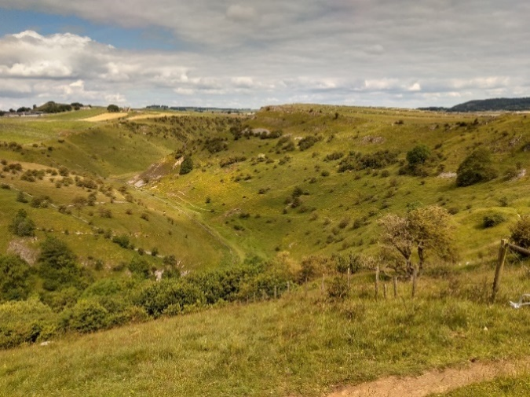
Refreshed, we soon arrived at Cressbrook where we swung right into Millers Dale, passing a large pond, the other side of it was ‘’Water-cum-Jolly Dale”, though strangely named it was very attractive and it seemed that we had now become very jollied up; John found a suitable area off the busy main path where we stopped for lunch.
We continued through Litton Mill – a magnificent restored property dating from the time of the industrial revolution which backs onto the River Wye. It was well stocked with large, healthy looking fish which we discovered when John took us down a narrow jitty to a bridge and across it. We continued on this route to emerge on the Monsal Trail, again this was very busy with many walkers plus cyclists and it seemed to have become much hotter. We found even more crowds at the Millers Dale Station Café where we had a short pit stop. (They serve huge cream teas, quickly scoffed down and highly rated by one of our group).
This station is also at the junction of our turn northwards up Monk’s Dale, at this point there is unbelievable steel bridging over the seriously deep gorge of the Wye, a testament to the skill of Victorian engineers but don’t look down if you get vertigo!
On completing Monk’s Dale we continued along the Limestone Way, enjoying a final break in a valley full of butterflies, wild flowers and bird song.

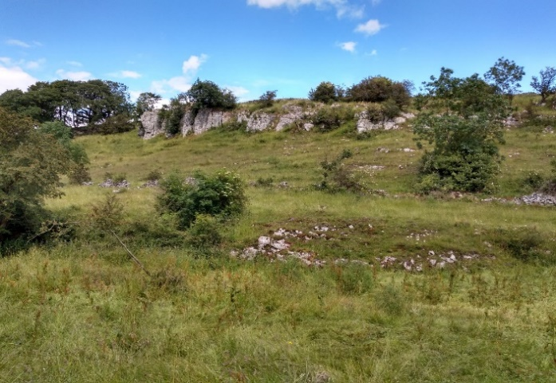
We then joined a quiet lane towards Wheston and along the way passed a group of “painted lady” butterflies feeding on blackberry flowers – these butterflies migrate to Britain to breed from southern Europe and Northern Africa and return before winter – amazing for a small insect.
At Wheston John showed us an interesting religious cross with the top missing. Later research dated it circa 1300’s when it was a marker on the Forest Road from Tideswell to Buxton, good that it’s preserved and to see. Imagine, in medieval times, along this route we would have been walking through a dense forest risking highway men and other ills, but now there’s road signposts, the biggest danger is traffic, sadly no forest and not an ancient tree to be seen!

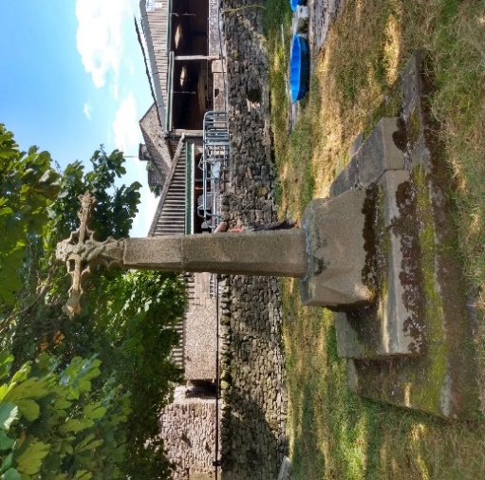
Further along we turned up a track through more stunning scenery towards Tideswell arriving at the Star Inn at about 4.30 pm, and much appreciated refreshments.

Many thanks to John for the very enjoyable walk with spectacular scenery and interesting features along the route and thanks to everyone in our group for their good company - it a was a very enjoyable day in the dales!

Mid-month walk – Langton Brewery Festival Walk Sunday July 14th
After a few wrong turns into the camping field, 19 walkers, including four visitors and an enthusiastic dog, met at the Langton Brewery ready to follow Sue on the 8-mile circular route.
We set out through the lovely village of Thorpe Langton, admiring the cottages, before heading down a track in the direction of Stonton Wyville. We crossed the stream, and several huge puddles which had appeared with overnight the rain, and walked between fields of wheat and barley. It was here that we began to get the views back to the village.
Just short of Stonton Wyville we took the path to climb towards Langton Caudle. On the way up we could identify several of the surrounding villages as well as a few species of butterfly which seemed to be enjoying the warm summer’s day as much as we were.
We paused at the trig point for photos (and a breather) and to admire the beautiful Leicestershire countryside.
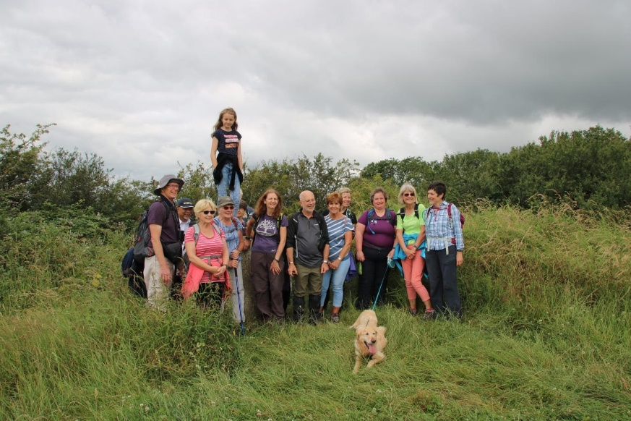
Setting off downhill on a bumpy, overgrown path, one of our party took a spectacular tumble down a bank but after taking a moment to recover from the experience she was able to continue unscathed.
Across the Welham Valley we could see, and discuss the various versions of the pronunciation of, Cranoe. We walked bravely through a herd of cattle who followed us at a distance, and made our way cautiously along a rabbit warren-strewn path following the hill top before descending in the direction of Welham.
We stopped for a coffee break at the bottom of the hill then walked the short distance along the quiet road into Welham village where we were greeted by a display of hundreds of beautiful hollyhocks growing against the stone walls.
Resisting the temptation to call in at the Red Lion, we carried on along Slawston Road before turning off at the bridleway and walking through the fields to the disused railway line, where we started our return homewards. The surroundings changed as we walked under the shade of the trees, following the course of the slowly moving River Welland back to Welham.
From Welham we took Bowden Lane, a route popular with cyclists, and finally turned to walk along the farm track, open especially for access to the brewery festival.
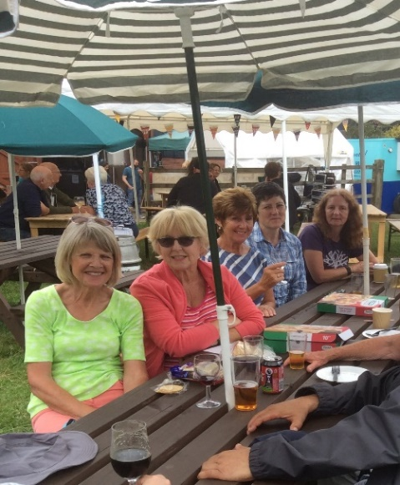
It was a lovely walk, with great views and great company, rounded off back at the Langton Brewery Festival where many of us stayed to sample the wonderful local beer and food, accompanied by live music.
Thank you, Sue. What a perfect way to spend a Sunday!

