NEWSLETTER – March 2020
Oadby Hillwalking Club www.oadbyhwc.com
ohwcmail@gmail.com

OHWC Committee 2019-2020
Chair: Jenny Fox 0116 2911491
Secretary/Newsletter: Catherine Gwinnett 07941855762
Treasurer: Alison Beckett 07557199247
Walks Co-ordinator: Geoff Mattock 0116 2395381
Membership Secretary: Carol Hinks 0116 2592144

Monthly Club Meetings
Monthly club meetings are held on the Wednesday following the Sunday walk at the Wigston Conservative Club, 38 Long Street, Wigston, Leicester, LE18 2AH at 7.30pm. All club members are welcome.

News and Events

OHWC AGM
7.30pm Wednesday 8th April 2020 at the Conservative Club, 38 Long Street, Wigston
The minutes from the 2019 AGM are on the OHWC website: oadbyhwc.com/club-information

Leeja Palace meal
Thanks to Sue for arranging the meal at Leeja Palace after the March walk. 18 people went and a good time was had by all. Watch this space for more social events……

Next monthly walk – Sunday 5th April, HADFIELD, Peak District Change of destination

Coach departs: Oadby Central Car Park (adjacent to the Trinity Methodist Church) at 8.00am. Please note the coach will leave Hadfield at 5.30pm.
Finishing point: The Palatine, Station Road, Hadfield, SK13 1AA
Coach Route: M1 (J29), A617, A619, A623, B6001, A6187, A6013, A57 to Glossop, then right into Hadfield.
Boot stop: Tibshelf
Map: Explorer OL1
Walk Leaders: Andy (long) Geoff (12) John (11) Adam (10) Anne (8)

Please contact Catherine ohwcmail@gmail.com if you would like to book a place on the coach or if you are unable to go and need to cancel.

Walk Report Blockley 1st March, from Yvonne Shepherd
On a bright and sunny St. David’s Day six of us plus our leader, Colin, set out on our walk to Blockley. We were dropped off at the edge of Willersey village and soon found our route along a disused railway track. We were struggling to find a left turn until we worked out that it was up the right embankment and over a footbridge in the style of a motorway slip road. We were now on route to Broadway which took us along Springfield Lane where we admired several large properties and their well-kept grounds. We entered the centre of Broadway via China Square, an area known for pottery making back in the day. We wandered up High street indulging in a bit of window shopping and from the estate agents got an idea of the value of the properties we had seen. Colin then took us to a tea shop and treated us to a hot drink. After using the facilities, we set off uphill to join the main path to Broadway Tower.
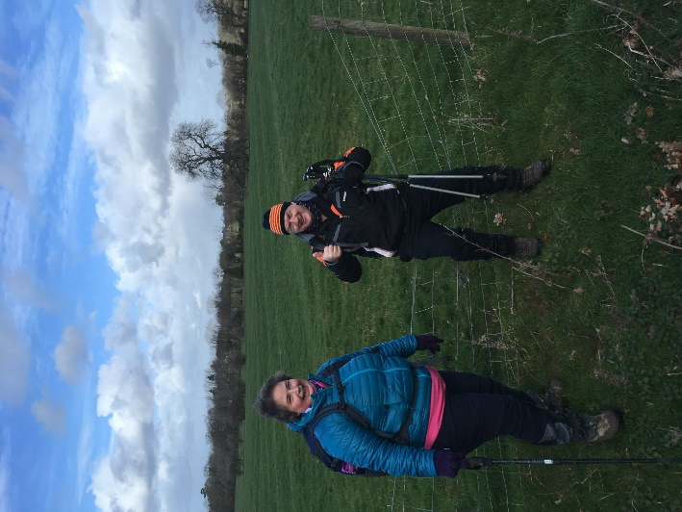
This involved crossing several boggy fields and climbing over wire fences which Colin sat on to lower them for us to climb over. We eventually found ourselves on the wrong side of a barbed wire fence - no sitting on this one! Paul climbed an old tree with a large branch overhanging the fence and dropped down the other side. Colin thought this was too risky so the rest of us walked back down the hill to the gate to join the main path to the tower. The path was steep and slippery but we made it to the top and after admiring the views we settled at some picnic tables for a lunch break. Our route now went downhill through extensive woodland. The recent winds had blown down a lot of old wood which made walking quite tricky. We crossed several large fields, one with water pumping equipment, and walked through an avenue of tall pine trees.

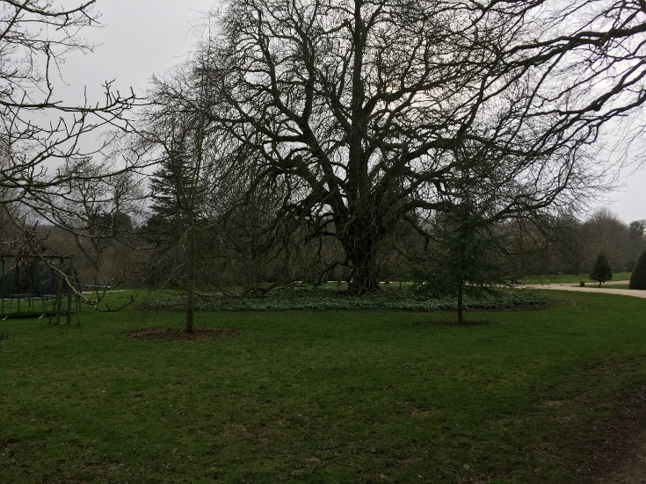
A steep uphill path led us to the A44. Across the road we joined a long driveway to the grand Upton Farm estate where we saw this huge old tree with a carpet of snowdrops beneath. After a short shower of rain we were greeted by a double rainbow over Blockley, arriving with time for a drink at the pub. Thank you Colin for a very enjoyable walk and the hot chocolate. Da iawn ti.

Mid-month walk Sunday 15th March
Keith Yeomans is leading an 7-8 mile walk from Foxton.
This walk is a different route from the one in February.
Meet at 9.45 near the church, ready to start at 10.00
You should be able to park in the street.

Walk reminder
Please make sure that you are carrying your completed Club Safety Form in the top of your rucksack - it could help you in a difficult situation. N.B. Don’t forget to keep the form up to date. The form is available on the Club Website oadbyhwc.com/essential-information/
Walk Route Map: Please go onto the News section of the Club website, www.oadbyhwc.com a few days before the monthly walk, to see a map showing the walk routes. Hopefully this will speed up selecting your walk when signing up on the coach.
Prospective walkers – please contact the group email address to book a seat on the bus this month: OHWCmail@gmail.com. You will receive a reply confirming the availability or otherwise of a seat. You are reminded that it is first come first served. If you delay booking you may not get a seat. Please do not turn up without booking and receiving confirmation that you have a place. You must book a place on the coach in advance or you may not be allowed on as it picks up at various places on the ring road members who have already booked a seat.
If you wish to be picked up, at other places than the Oadby Car Park, please mention where when booking and please be aware that very occasionally another Woods coach may go past before ours arrives.
Members can book for the next month’s walk on the return journey back to Oadby. You don’t have to wait for the Club meeting or the Newsletter.
Bus Fares – preferably by cheque payable to “Oadby Hillwalking Club” or simply “O.H.W.C.”
Adult Members £12, Junior/Student Members £5, Guests/Visitors + £3. (subject to review at the AGM)

Cancellations - members and guests - Cancellations up to Tuesday Midnight before the Sunday walk - no penalty. Cancellations thereafter - full cost of the bus fare due. (AGM 2011). Please send fare due to the Treasurer, Alison Beckett, 5 Spinney View, Great Glen, Leics, LE8 9EP

Boot/Toilet Stop
Members are urged to keep the time taken at the boot stop to a minimum. At the end of the walk members should change their footwear and place dirty boots and rucksacks in the luggage locker before getting onto the coach, thus avoiding any congestion and mud in the coach.
Those getting off the coach at Fosse Park and the Ring Road, may alternatively, put your dirty kit into a “Bin Liner” and then take it onto the coach; thus negating having to search for your kit in the bus Luggage Locker.

Interested in being a Walk Leader? Please speak to any Committee Member, who will gladly arrange this for you – or better still come along to our Club Meetings.
Safety: The club walk organisers are not qualified guides. You join them at your own risk and of your own free will. You are part of an autonomous group, responsible for your own safety and happy to accept the discretion and actions of any or all the participants on that organised walk or activity in the event of injury to you, the need to have you rescued or otherwise.
Essential Wear - N.B. Jeans and, or trainers/sandals are NOT suitable
Members and guests must be suitably equipped and as a minimum this must include:
❖ suitable walking boots
❖ waterproof coat and over-trousers
❖ warm clothing
❖ an appropriate rucksack.
❖ food and drink for the whole day
❖ a First Aid Kit is recommended
If you are not properly equipped for hillwalking, you may not be able to participate.
Please do not wear dirty boots on the coach.
Only Registered Assistance Dogs are allowed on club walks, except on mid-month walks at the discretion of the walk leader.

Sunday Monthly Walks by coach: 2020
Return departure is at 5pm during GMT and 5.30pm during BST.
5 April Hadfield – Peak District
3 May Symonds Yat - Wye Valley

Almoner’s Report
If you know of any member who is poorly or unable to walk for any reason, please let one of the committee know.

