**NEWSLETTER - May 2019**

**Oadby Hillwalking Club**

[www.oadbyhwc.com](http://www.oadbyhwc.com/)

**OHWC COMMITTEE 2019-20**

Chairperson: Jenny Fox 0116-2911491

Secretary/Newsletter: Catherine Gwinnett 07941855762

Treasurer: Alison Beckett 07557 199247

Walks Co-ordinator: Geoff Mattock 0116-2395381

Social: Eileen Pott 0780 0774029

Membership Secretary: Carol Hinks 0116-2592144

**Annual membership subs are due. For a membership form and details of how to pay, please go to the website:** [**oadbyhwc.com/membership**](http://oadbyhwc.com/membership)

**Monthly walks reminder – if you have signed up for a place on the coach and can no longer go, please contact Carol ohwcmail@gmail.com as there may be people on the waiting list who would love the chance to take up a spare seat. Thanks**

**Dates for your Diaries:**

**Snowdonia Weekend Friday 19th – Sunday 21st July 2019**

Geoff Mattock is planning a walking weekend in Wales. Members will need to sort their own accommodation and transport ASAP. Dolgam B&B tel 01690 720228 and campsite just turn up. If you would like to attend this weekend or find out more please contact Geoff.

**Langton Brewery Festival Walk Sunday 14th July 2019**

Sue Dyson is leading a circular walk ending at the Langton Brewery Festival. Drinks and food will be available. More details in the next newsletter,

**May Mid Month Walk**

Sunday 26th May 2019 Leader Catherine Gwinnett

Meet at the Village Green, Billesdon at 9:30am

Distance approx 9 miles

**Next monthly walk Sunday 2nd June Wendover, Chilterns**

**Coach departs:** Oadby Central Car Park (adjacent to the Trinity Methodist Church) at **8.00am** and will leave The White Swan, Wendover at **5:30**pm.

**Coach Route:** M69, A46, M40 J5, A40, A4010, A413, B4009

**Boot stop:** Cherwell Valley services

**Maps: OS Explorer 181/171**

**Walk Leaders** Mike Hinks (8), Colin Gracey (10), Adam Wakley (12), Geoff Mattock (14), Carol Birch (long)

**Walk Routes.** To Mike Hinks, preferably as a gpx file or as a JPEG file by **Thursday 23rd May** please. mike.hinks19@gmail.com

**Walk Route Map**

*Please go onto the News section of the Club website,*[www.oadbyhwc.com](http://www.oadbyhwc.com/)*a few days before the monthly walk, to see a map showing the walk routes.* *Hopefully this will speed up selecting your walk when signing up on the coach.*

**Prospective walkers – please contact the group email address to book a seat on the bus this month:** OHWCmail@gmail.com. You will receive a reply confirming the availability or otherwise of a seat. You are reminded that it is first come first served. If you delay booking you may not get a seat. Please do not turn up without booking and receiving confirmation that you have a place. You must book a place on the coach in advance or you may not be allowed on as it picks up at various places on the ring road members who have already booked a seat.

If you wish to be picked up, at other places than the Oadby Car Park, please mention where when booking and please be aware that very occasionally another Woods coach may go past before ours arrives.

Members can book for the next month’s walk on the return journey back to Oadby. You don’t have to wait for the Club meeting or the Newsletter.

**Bus Fares –** preferably by cheque payable to “Oadby Hillwalking Club” or simply “O.H.W.C.”

Adult Members £12, Junior/Student Members £5, Guests/Visitors + £3. (subject to review at the AGM)

**Cancellations - members and guests *- Cancellations up to Tuesday Midnight before the Sunday walk - no penalty. Cancellations thereafter - full cost of the bus fare due. (AGM 2011).******Please send fare due to the Treasurer, Alison Beckett, 5 Spinney View, Great Glen, Leics, LE8 9EP***

**Boot/Toilet Stop**

**Members are urged to keep the time taken at the boot stop to a minimum.** At the end of the walk members should change their footwear and place dirty boots and rucksacks in the luggage locker before getting onto the coach, thus avoiding any congestion and mud in the coach.

***Those getting off the coach at Fosse Park and the Ring Road, may alternatively, put your dirty kit into a “Bin Liner” and then take it onto the coach; thus negating having to search for your kit in the bus Luggage Locker.***

**Interested in being a Walk Leader?** Please speak to any Committee Member, who will gladly arrange this for you – or better still come along to our Club Meetings.

**Monthly Club Meetings**

Monthly club meetings are held on the Wednesday following the Sunday walk at the Wigston Conservative Club, 38 Long Street, Wigston, Leicester, LE18 2AH at 7.30pm. All club members are welcome.

**Safety Form and Emergency Personal Details**

Please make sure that you are carrying your completed Club Safety Form in the top of your rucksack - it could help you in a difficult situation. N.B. Don’t forget to keep the form up to date. The form is available on the Club Website www.oadbyhwc.com

The club walk organisers are not qualified guides. You join them at your own risk and of your own free will. You are part of an autonomous group, responsible for your own safety and happy to accept the discretion and actions of any or all the participants on that organised walk or activity in the event of injury to you, the need to have you rescued or otherwise.

Essential Wear - N.B. Jeans and, or trainers/sandals are NOT suitable

Members and guests must be suitably equipped and as a minimum this must include:

❖ Suitable walking boots

❖ waterproof coat and over-trousers

❖ warm clothing

❖ an appropriate rucksack.

❖ food and drink for the whole day

❖ a First Aid Kit is recommended

If you are not properly equipped for hillwalking you may not be able to participate.

Please do not wear dirty boots on the bus even at the start of the day.

Only “Registered Assistance Dogs” are allowed on club walks except on midmonth walks at the discretion of the walk leader.

**Sunday Monthly Walks by coach: 2019/2020**

Returns at 5pm during GMT and 5.30pm during BST.

2019

2 June Wendover – Chilterns, Bucks

7 July Hayfield – Peak District

4 Aug Knighton - west of M6, Staffs

1 Sept Painswick – Cotswolds

6 Oct Tideswell – Peak District

3 Nov Hope – Peak District

1 Dec Ambergate – Peak District

2020

5 Jan Monyash – Peak District

2 Feb Bradwell – Peak District

1 Mar Blockley – Cotswolds

5 April Symonds Yat - Wye Valley

10 May Hadfield – Peak District

**Almoner’s Report**

*If you know of any member that is poorly or unable to walk for any reason, please let one of the committee know.*

**May Walk Report 12th May – Cleeve Hill, Cotswolds**

**Cleeve Hill Short Walk Report by Mike Hinks**

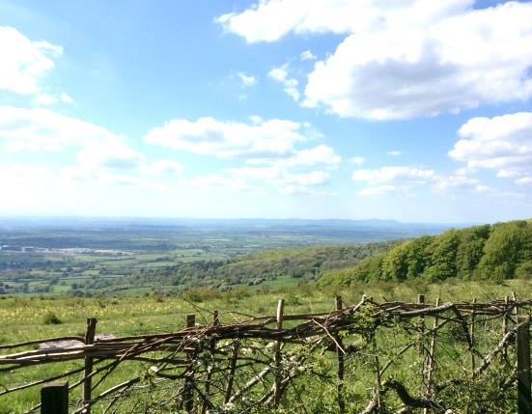Eleven souls we were who stayed on the bus until the very end, until it reached Cleeve Hill.

The bus driver took us some way past The Rising Sun which was our intended starting point but we soon found a footpath between houses leading up onto the Common, where there were many footpaths leading in all sorts of directions.

Our intention was to walk in a clockwise direction, however when we reached the Golf Club House we joined the Cotswolds Way, but went in the wrong direction, we decided to continue the walk anti-clockwise!

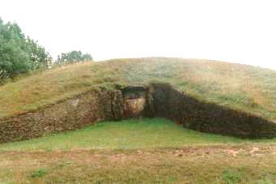A lovely warm day had brought out lots of people walking on the numerous paths and tracks on the Common. Walking up to the View Point we had to dodge the golfers and their flying balls. Joining the Winchcombe Way we passed several tall masts on our way to the Belas Knap Long Barrow – a Neolithic, chambered long barrow with a false entrance and side chambers. Thereafter we re-joined the Cotswolds Way walking around the edge of the Common, once again passing the Clubhouse on our way back to The Rising Sun, where refreshing drinks were most welcome before boarding the bus back to Oadby.

Thanks to Carol for an interesting walk.